Sampreet Klair_DBS311_ZRAL_Lab3

Question 1: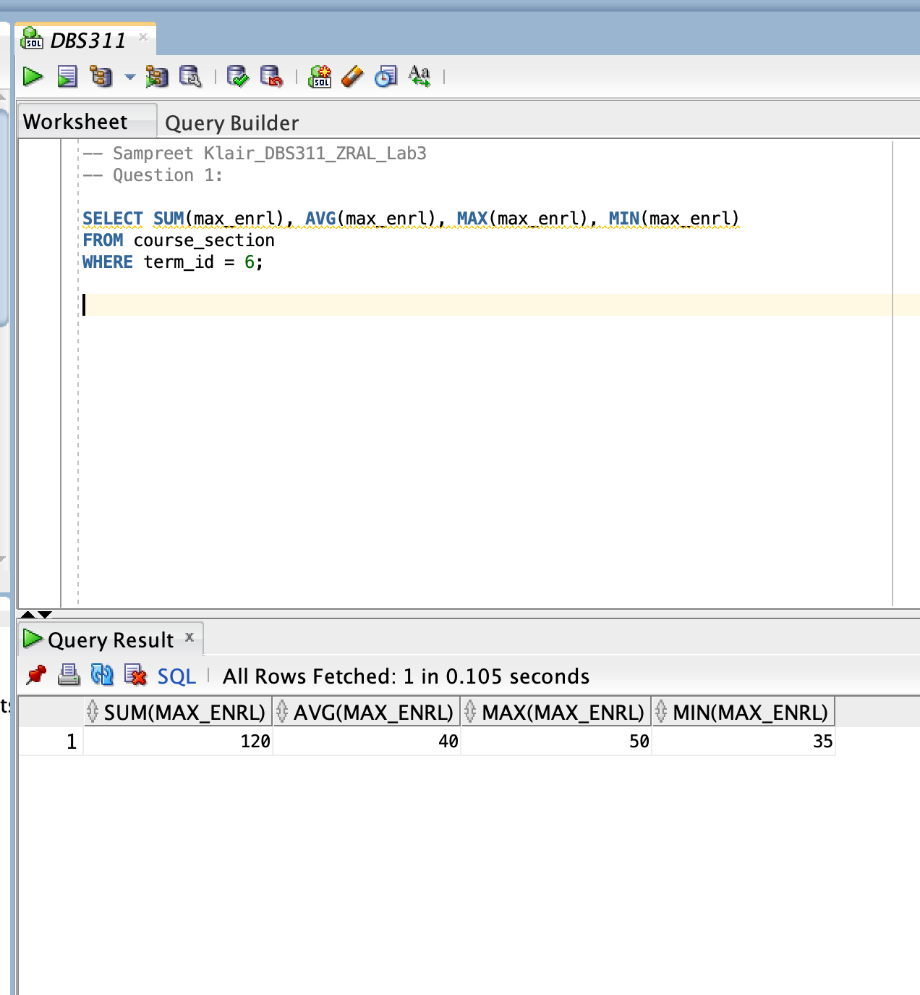

Question 2: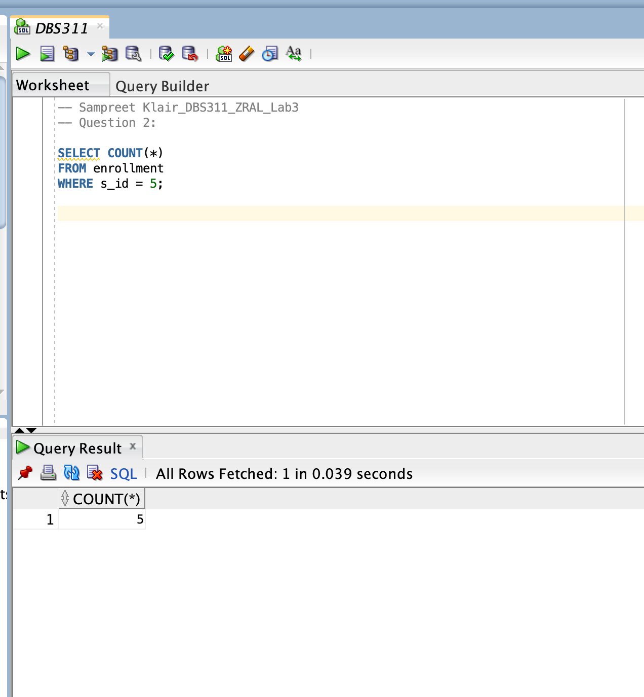

Question 3: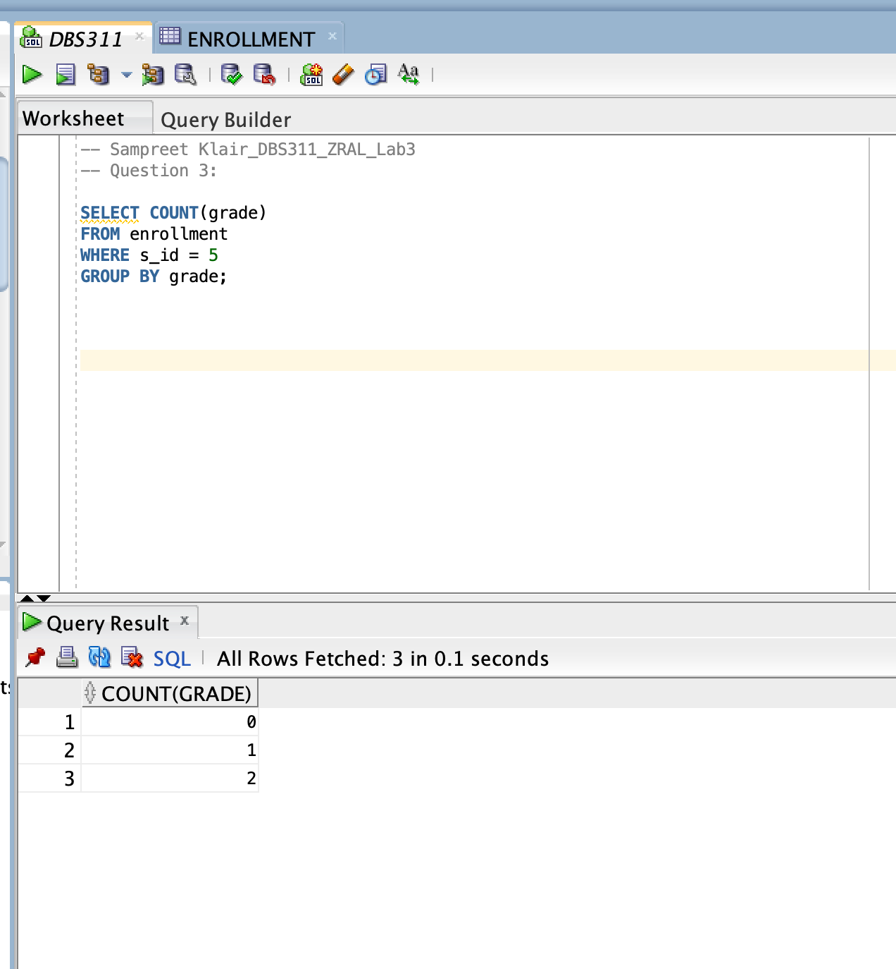

Question 4:

Question 5:

Question 6:

Question 7:

Question 8:

Question 9:

Question 10:

Question 11:

Question 12:

Question 13:

